Assignment-5

DATA STRUCTURES
LINKED LIST:
NAME-Harsh
ROLL NO-1024030497
BATCH-2C25
Ques-1)
Solution:
#include <iostream>
using namespace std;

class Node {
public:
int data;
Node* next;
Node(int val, Node* nxt = nullptr) {
data = val;
next = nxt;
}

};

class LinkedList {
Node* head;
public:
LinkedList() { head = nullptr; }

void insertAtBeginning(int val) {
Node* temp = new Node(val, head);
head = temp;
}

void insertAtEnd(int val) {
Node* temp = new Node(val);
if (!head) {
head = temp;
return;
}
Node* curr = head;
while (curr->next) curr = curr->next;
curr->next = temp;
}

void insertBefore(int target, int val) {
if (!head) return;
if (head->data == target) {
insertAtBeginning(val);
return;
}
Node* curr = head;
while (curr->next && curr->next->data != target)
curr = curr->next;
if (curr->next) {
Node* temp = new Node(val, curr->next);
curr->next = temp;
}
}

void insertAfter(int target, int val) {
Node* curr = head;
while (curr && curr->data != target)
curr = curr->next;
if (curr) {
Node* temp = new Node(val, curr->next);
curr->next = temp;
}
}

void deleteFromBeginning() {
if (!head) return;
Node* temp = head;
head = head->next;
delete temp;
}

void deleteFromEnd() {
if (!head) return;
if (!head->next) {
delete head;
head = nullptr;
return;
}
Node* curr = head;
while (curr->next->next)
curr = curr->next;
delete curr->next;
curr->next = nullptr;
}

void deleteSpecific(int val) {
if (!head) return;
if (head->data == val) {
deleteFromBeginning();
return;
}
Node* curr = head;
while (curr->next && curr->next->data != val)
curr = curr->next;
if (curr->next) {
Node* temp = curr->next;
curr->next = temp->next;
delete temp;
}
}

void search(int val) {
Node* curr = head;
int pos = 1;
while (curr) {
if (curr->data == val) {
cout << "Found at position: " << pos << endl;
return;
}
curr = curr->next;
pos++;
}
cout << "Not found\n";
}

void display() {
Node* curr = head;
while (curr) {
cout << curr->data << " ";
curr = curr->next;
}
cout << endl;
}

void menu() {
int choice, val, target;
while (true) {
cout << "\n1.Insert at Beginning\n2.Insert at End\n3.Insert Before\n4.Insert After\n5.Delete from Beginning\n6.Delete from End\n7.Delete Specific\n8.Search\n9.Display\n10.Exit\nChoice: ";
cin >> choice;
switch (choice) {
case 1: cin >> val; insertAtBeginning(val); break;
case 2: cin >> val; insertAtEnd(val); break;
case 3: cin >> val >> target; insertBefore(target, val); break;
case 4: cin >> val >> target; insertAfter(target, val); break;
case 5: deleteFromBeginning(); break;
case 6: deleteFromEnd(); break;
case 7: cin >> val; deleteSpecific(val); break;
case 8: cin >> val; search(val); break;
case 9: display(); break;
case 10: return;
}
}
}
};

int main() {
LinkedList list;
list.menu();
return 0;
}
OUTPUT
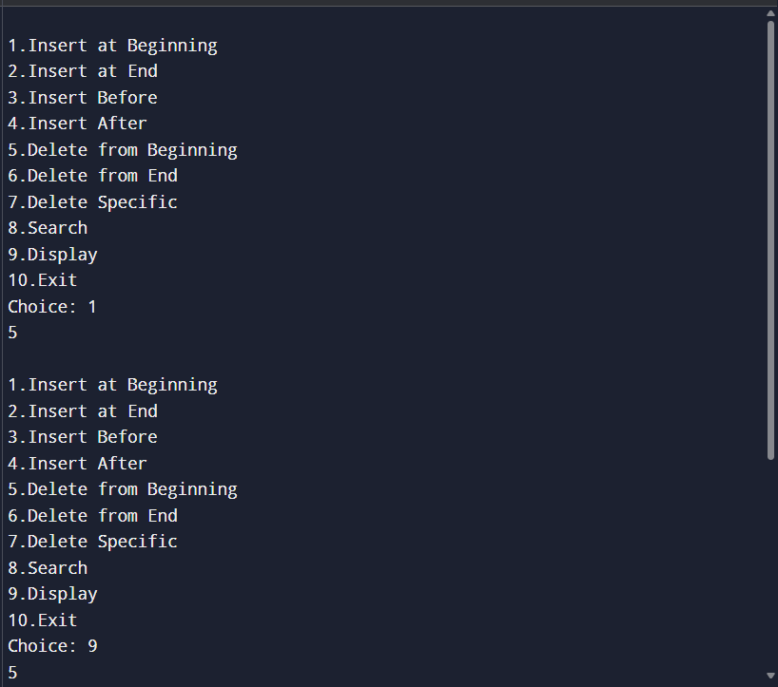
Ques-2)
Solution:
#include <iostream>
using namespace std;

struct Node {
int data;
Node* next;
Node(int val, Node* nxt = nullptr) {
data = val;
next = nxt;
}
};

void countAndDelete(Node*& head, int key) {
int count = 0;

while (head && head->data == key) {
Node* temp = head;
head = head->next;
delete temp;
count++;
}

Node* curr = head;
while (curr && curr->next) {
if (curr->next->data == key) {
Node* temp = curr->next;
curr->next = temp->next;
delete temp;
count++;
} else {
curr = curr->next;
}
}

cout << "Count: " << count << endl;
curr = head;
while (curr) {
cout << curr->data;
if (curr->next) cout << "->";
curr = curr->next;
}
cout << endl;
}

int main() {
Node* head = new Node(1);
head->next = new Node(2);
head->next->next = new Node(1);
head->next->next->next = new Node(2);
head->next->next->next->next = new Node(1);
head->next->next->next->next->next = new Node(3);
head->next->next->next->next->next->next = new Node(1);

int key = 1;
countAndDelete(head, key);
return 0;
}
OUTPUT
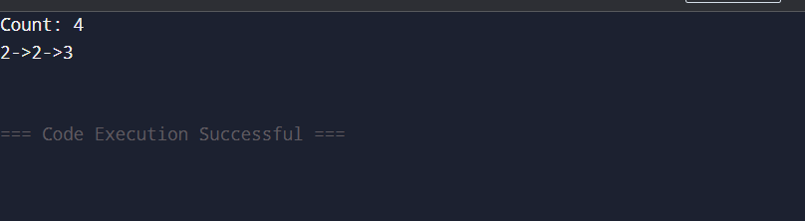
Ques-3)
Solution:
#include <iostream>
using namespace std;

struct Node {
int data;
Node* next;
Node(int val) {
data = val;
next = nullptr;
}
};

Node* findMiddle(Node* head) {
Node* slow = head;
Node* fast = head;
while (fast && fast->next) {
slow = slow->next;
fast = fast->next->next;
}
return slow;
}

int main() {
Node* head = new Node(1);
head->next = new Node(2);
head->next->next = new Node(3);
head->next->next->next = new Node(4);
head->next->next->next->next = new Node(5);

Node* middle = findMiddle(head);
if (middle)
cout << middle->data << endl;
return 0;
}
OUTPUT
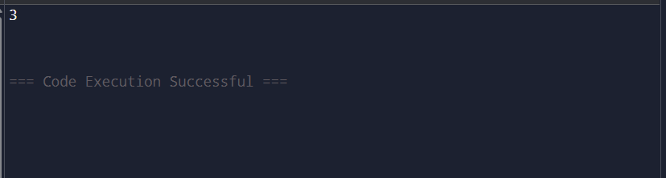
Ques-4)
Solution:
#include <iostream>
using namespace std;

struct Node {
int data;
Node* next;
Node(int val) {
data = val;
next = nullptr;
}
};

Node* reverseList(Node* head) {
Node* prev = nullptr;
Node* curr = head;
while (curr) {
Node* next = curr->next;
curr->next = prev;
prev = curr;
curr = next;
}
return prev;
}

void printList(Node* head) {
while (head) {
cout << head->data;
if (head->next) cout << "->";
head = head->next;
}
cout << "->NULL\n";
}

int main() {
Node* head = new Node(1);
head->next = new Node(2);
head->next->next = new Node(3);
head->next->next->next = new Node(4);

head = reverseList(head);
printList(head);
return 0;
}
OUTPUT
